**Note:**

1. Please make sure you complete this Report related to each meeting for your Practical Project – Iteration 1 below.

2. Once completed, convert this content to readme.md (GitHub).

Practical Project – Iteration 1

Group Meeting Report

|  |  |
| --- | --- |
| Notice of Meeting and Agenda | Date 28th September 2021Time 3:00 PMLocation 401-ZYU |

|  |  |  |  |
| --- | --- | --- | --- |
|  | | | |
| Sponsor: | Noor Alani | Name of Group: | Group 33 |
| Group Lead: | Violet | Note taker: | Violet, Avocado |
| **Attendees:** | Showily, Violet, Avocado, Red | | |
| **Absent:** | NA | | |
| **Please bring:** | Laptop, Mobile phone, ipad | | |
| **Agenda items:** | 1. Determine the division of labor in stakeholders 2. Create a profile 3. Convert information to Markdown | | |

# Minutes

|  |  |  |  |
| --- | --- | --- | --- |
| Agenda Item 1: | Stakeholder register | Presenter: | Avocado |

#### Discussion:

Avocado identified the main stakeholder in this project, their roles, and impacts.

#### Conclusions:

There four people involved in the project.

| Action items | Person responsible | Deadline |
| --- | --- | --- |
| * Record stakeholders’ names | Violet | 14th Sep 2021 |
| * Include their role | Showily | 14th Sep 2021 |
| * Include their impact | Avocado | 14th Sep 2021 |

|  |  |  |  |
| --- | --- | --- | --- |
| Agenda Item 2: | Persona | Presenter: | Showily |

#### Discussion:

We need to include persona to help us understand the main users of our project.

#### Conclusions:

Draw three personas

| Action items | Person responsible | Deadline |
| --- | --- | --- |
| * Persona (motivation, quote) | Avocado | 23rd Sep 2021 |
| * Persona (brand, photo) | Violet | 23rd Sep 2021 |
| * Persona (collate information) | Red | 23rd Sep 2021 |
| * Persona (frustration, challenge) | Showily | 23rd Sep 2021 |

|  |  |  |  |
| --- | --- | --- | --- |
| Agenda Item 3: | Make a review | Presenter: | Violet |

#### Discussion:

How to make a conclusion.

#### Conclusions:

To include first and final impressions as a user and whether they are relevant.

| Action items | Person responsible | Deadline |
| --- | --- | --- |
| * Include the first impression | Showily | 30th Sep 2021 |
| * Include the final impression | Violet | 30th Sep 2021 |
| * Integrate them | Red | 30th Sep 2021 |
| * Include the users who are relevant | Avocado | 30th Sep 2021 |

# Other Information

#### Resources:

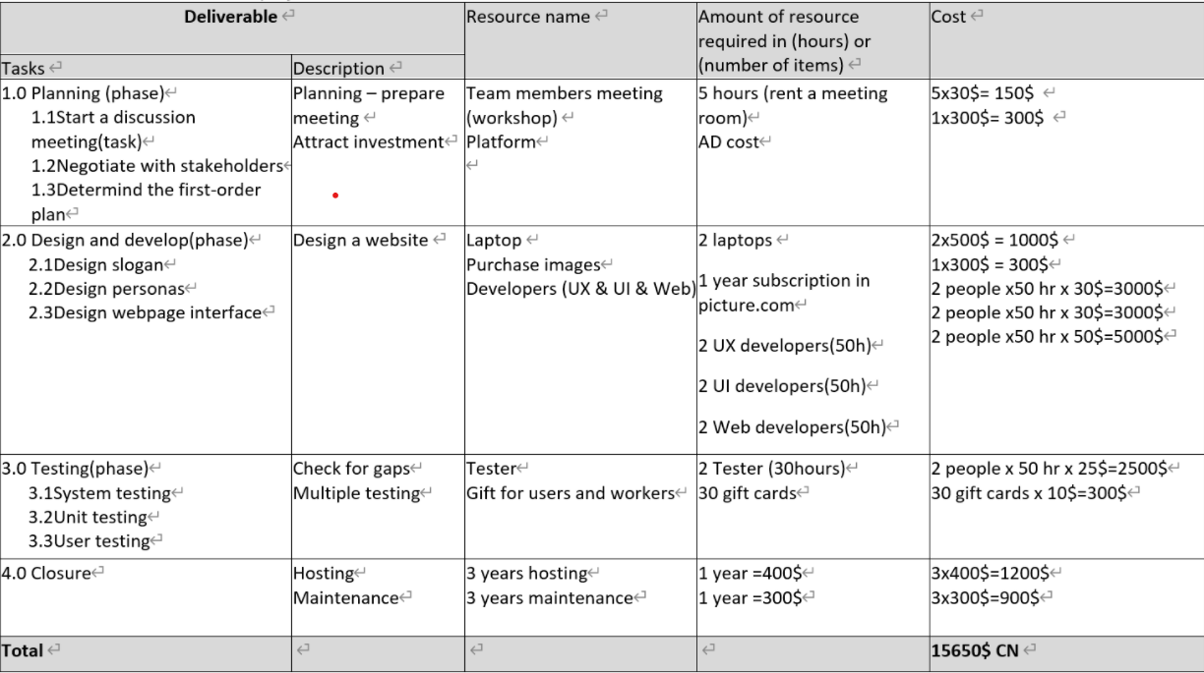

#### Date of next meeting:

12th Oct. 2021